**NEW PATIENTS**

At the Ivy Dental Practice, we provide a mixture of NHS, private and Denplan options for New patients. NHS patients are welcome if we are not at full capacity, this can be checked at reception.

**ADDITIONAL SERVICES**

At the practice we offer additional treatments including tooth whitening, botox, dermal fillers, laser treatment, C-Fast, acupuncture and implants.

**PATIENT NOTICE**

We would ask patients to arrive on time for their appointment, as it may not be possible to undertake the planned treatment if you are late.

As an extra courtesy We now send recalls/reminders via text & email. To consent to these reminders please complete a form at reception.

ACCESS TO THE PREMISES:

We have 2 surgeries located on the ground floor and 1 on the first floor. For our disabled and/or wheelchair users we have a mobile access ramp at the rear of the building. Should you require access to the building via our ramp please advise of booking an appointment.

## **VIOLENT AND ABUSIVE BEHAVIOUR**

We have a zero-tolerance policy against violent, abusive, racism, homophobic, biphobia and transphobia towards any of our staff or patients. Anyone displaying behavior of this kind will be refused further appointments, and prosecution may succeed.

**DATA PROTECTION ACT 1998 AND PATIENT CONFIDENTIALITY**

We take data protection and confidentiality very seriously at the practice. Only authorised members of the clinical team have access to dental records and personal information. Should you wish to see your dental records, please speak to your dentist who will advise you of the procedure.

Your personal & dental records will remain confidential, secure and property of the practice.

If you wish to discuss sensitive issues away from the reception area, then please feel free to ask to speak to a member of staff privately and we will endeavour to talk to you in a separate room.

**CANCELLATIONS AND FAILED APPOINTMENTS**

We require at least 48 hours’ notice if you wish to cancel your appointment, this gives us the chance to fill the appointment time with other patients.

The NHS has a policy regarding failed appointments which we follow. After the first missed appointment we will contact you to inform you of this; if further appointments are then not attended following the initial missed appointment, we may refuse to book any further

appointments in the future due to wasted surgery time.

**NHS CHARGES AND EXEPMPTIONS**

Some NHS patients are entitled to either full or partial exemption from charges. If you think you may qualify for an exemption, please check below.

# People under 18 (19 if in full time education)

# Families receiving Working Families Tax Credits (check your certificate)

# Income Based Jobseekers Allowance

* Income Related Employment and Support Allowance

# Income support

# HC2 certificate

# Pregnant ladies or nursing mothers

* People receiving Pension Credit Guarantee credit
* If you are in prison or a young offenders institution
* Universal Credit

Evidence of exemption must be brought to each dental appointment.

**NHS CURRENT CHARGES**

Charges are based over 3 bands:

**Band 1:** £22.70 which covers emergency treatment and also routine exams, x-rays & basic scaling,

**Band 2:** £62.10, covers fillings, extensive scaling, root treatments & extractions

**Band 3:** £269.30 covers crown, bridge & denture work.

We provide cost estimates prior to commencement of dental treatment.

Payments can be made by cash, credit or debit card.

**TEAM IVY**

**Principal Dentist and Practice Director:**

Dr Malc Newsome BDS (GDC No: 74314)

**Associate Dentists:**

Dr Mahfuza Mannan (GDC No: 75774)

Dr Rabiya Khan (GDC No: 271638)

Dr Alex Borges (GDC No: 274484)

**Practice Manager and Director:**

Mrs Rachel Newsome (GDC No: 106211)

**Hygienist:**

Mrs Brigitte Hashmi (GDC No: 4883)

**Office Manager:**

Claire Seaton (GDC 243313)

**Receptionist:**

Mrs Annette Twiddy

**Dental Nurses:**

Miss Adele Gow (GDC No: 187131)

Miss Heather Lightfoot (GDC No: 151924)

Miss Kerry Sawyer (GDC No: 125142)

**Apprentice Dental Nurses:**

Amy Roberts

Ella Gaskell

You can express a preference about which dentist you see and endeavour to accommodate your request, but this may not always be possible.

# **COMPLAINTS AND COMPLIMENTS**

We aim to make your experience at the Ivy practice as pleasant as possible. If you have any complaints or compliments regarding our practice, you can approach any member of our team or write to Rachel Newsome, our Practice Manager. We take all complaints very seriously and will address all complaints promptly.

Any compliments you have let us know we are doing something right, there is a box at reception for your comments.

**CANCELLATIONS AND FAILED APPOINTMENTS**

We require at least 48 hours’ notice if you wish to cancel your appointment, this gives us the chance to fill the appointment time with other patients.

The NHS has a policy regarding failed appointments which we follow. After the first missed appointment we will contact you to inform you of this; if further appointments are then not attended following the initial missed appointment, we may refuse to book any further appointments in the future due to wasted surgery time.

**EMERGENCY COVER**

When the practice is closed emergency cover is provided by the NHS out-of-hours service. Please only contact them if you have a genuine dental emergency out of our opening hours on 0333 332 3800. Further details can be found on our answer-machine message.

**Parking** is available behind the Masonic Guildhall next door for a small charge

**NHS England information**

Tel 0300 3112233

Email: [england.contactus@nhs.net](mailto:england.contactus@nhs.net)

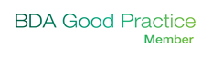

ICAS Number: 0845 120 3735

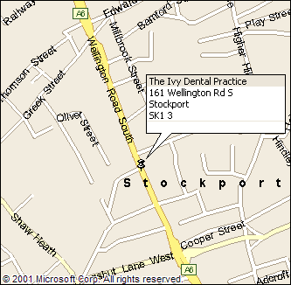

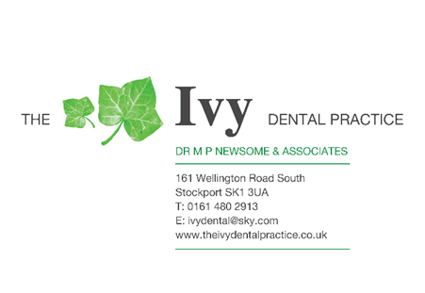



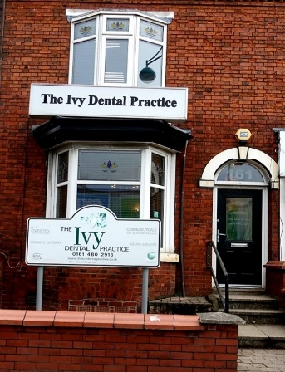

# **WELCOME TO THE IVY DENTAL PRACTICE**

161 Wellington Road South

Stockport

SK1 3UA

Tel: 01614802913

Email: [Ivydental@sky.com](mailto:Ivydental@sky.com)

www.theivydentalpractice.co.uk

Opening hours:

Monday to Friday

8.40 to 5.30